Point Gap

Definition
# Source: AI Source: Provided by: [Data Path: Persons Table -> ID Column: 1, Name_En Column: Motasem Essam] -> From: [ChatGPT] on [7/25/2026]
A Point Gap is the separation between two distinct points, measured by the distance between those points.
If $A$and $B$are two points, the point gap is:
$$\boxed{g=d\left(A , B\right)}$$
A positive point gap exists when:
$$\boxed{A≠B⇒g>0}$$
If the two points coincide, the gap is zero:
$$\boxed{A=B⇒g=0}$$
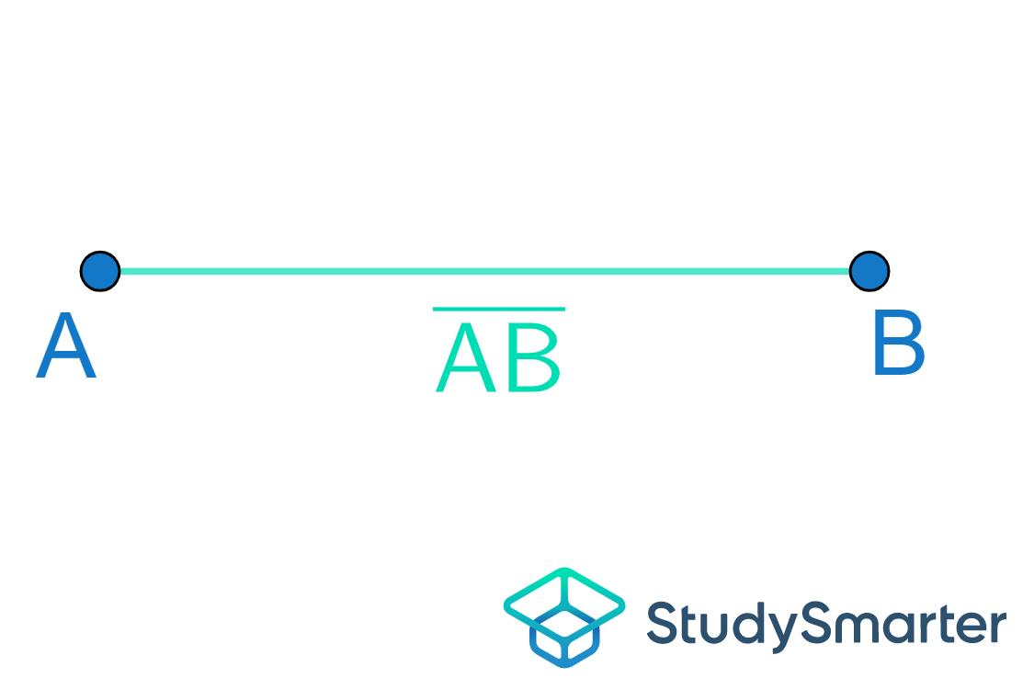
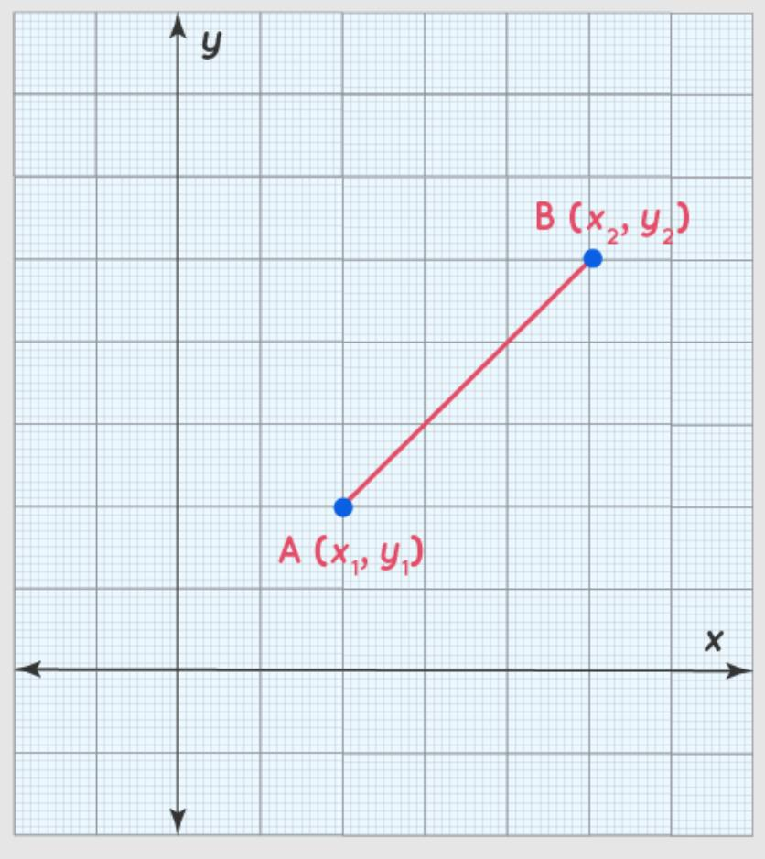
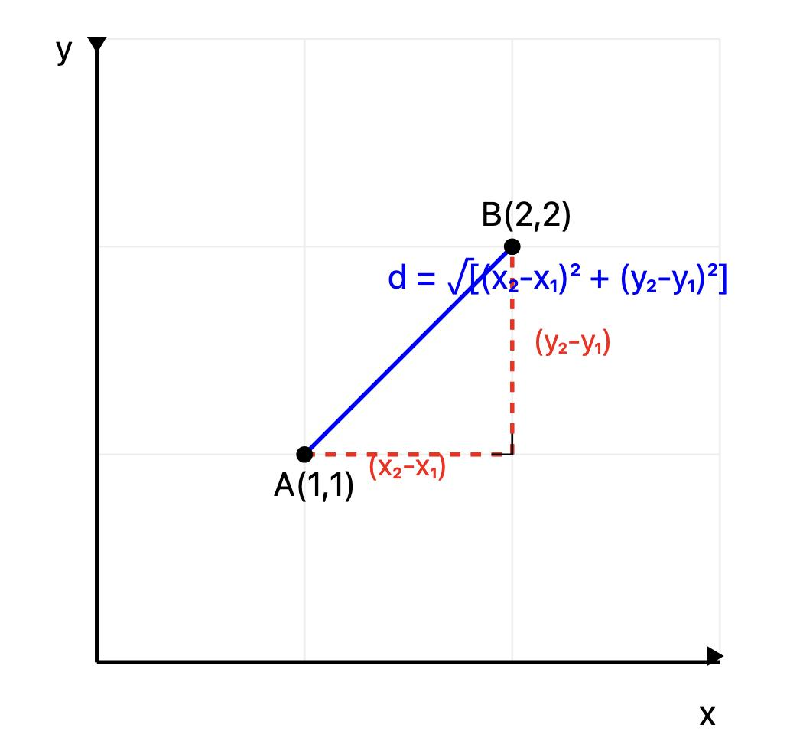
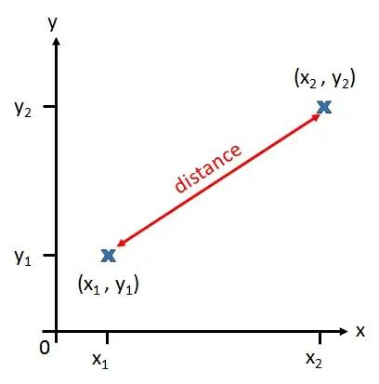
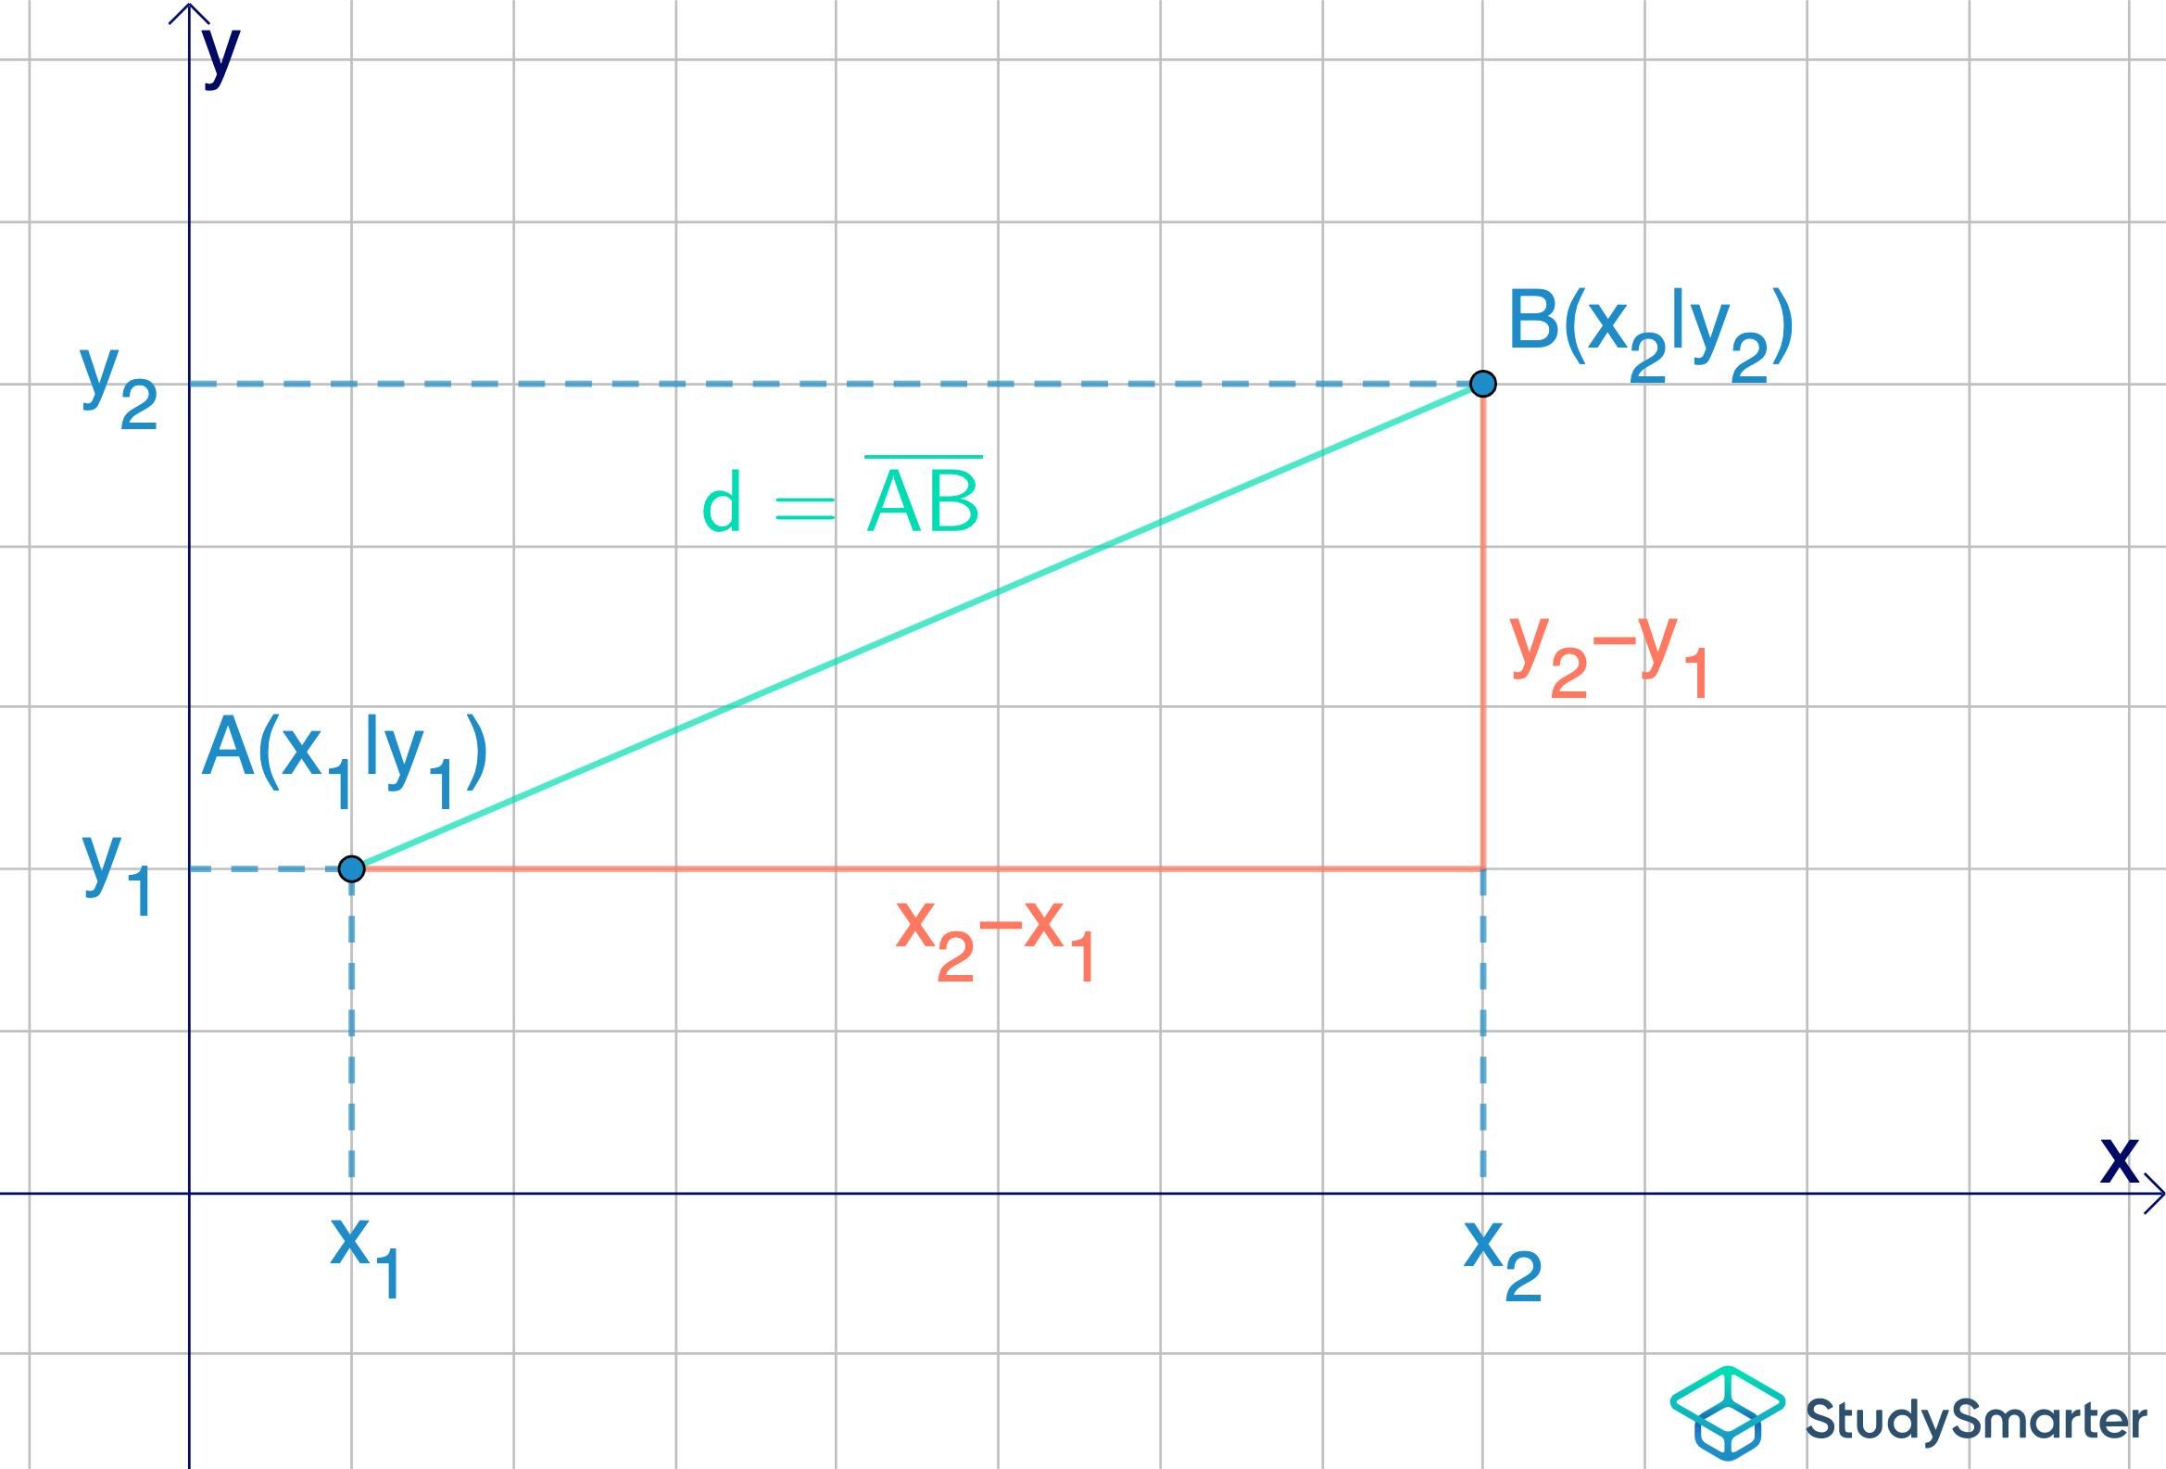

Purpose
# Source: AI Source: Provided by: [Data Path: Persons Table -> ID Column: 1, Name_En Column: Motasem Essam] -> From: [ChatGPT] on [7/25/2026]
A Point Gap is used to:
- Describe the space separating two points.
- Measure the separation between points.
- Determine whether two points are distinct or coincident.
- Define spacing between points in coordinate geometry.
- Analyze positions of points in one-, two-, or three-dimensional space.

Fundamental Concept
# Source: AI Source: Provided by: [Data Path: Persons Table -> ID Column: 1, Name_En Column: Motasem Essam] -> From: [ChatGPT] on [7/25/2026]
For two points:
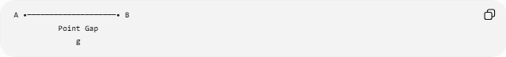
A •────────────────────• B
Point Gap
g
The gap is the distance from $A$to $B$.
$$\boxed{g=AB}$$
Distance is always non-negative:
$$\boxed{g≥0}$$

Mathematical Representation

1. One-Dimensional Points
# Source: AI Source: Provided by: [Data Path: Persons Table -> ID Column: 1, Name_En Column: Motasem Essam] -> From: [ChatGPT] on [7/25/2026]
For points $A\left(x_{1}\right)$and $B\left(x_{2}\right)$:
$$\boxed{g=∣x_{2}-x_{1}∣}$$
Example:
$$A=3, B=11 \\ g=∣11-3∣=8$$
Therefore:
$$\boxed{g=8}$$

2. Two-Dimensional Points
# Source: AI Source: Provided by: [Data Path: Persons Table -> ID Column: 1, Name_En Column: Motasem Essam] -> From: [ChatGPT] on [7/25/2026]
For:
$$A\left(x_{1} , y_{1}\right), B\left(x_{2} , y_{2}\right)$$
the point gap is:
$$\boxed{g=\sqrt{{\left(x_{2}-x_{1}\right)}^{2}+{\left(y_{2}-y_{1}\right)}^{2}}}$$
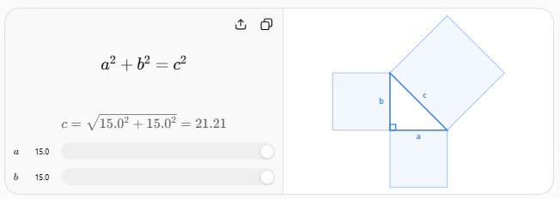
The formula follows from the Pythagorean theorem applied to the horizontal and vertical differences between the two points.

3. Three-Dimensional Points
# Source: AI Source: Provided by: [Data Path: Persons Table -> ID Column: 1, Name_En Column: Motasem Essam] -> From: [ChatGPT] on [7/25/2026]
For:
$$A\left(x_{1} , y_{1} , z_{1}\right)$$
and
$$B\left(x_{2} , y_{2} , z_{2}\right)$$
the point gap is:
$$\boxed{g=\sqrt{{\left(x_{2}-x_{1}\right)}^{2}+{\left(y_{2}-y_{1}\right)}^{2}+{\left(z_{2}-z_{1}\right)}^{2}}}$$

Types of Point Gaps
# Source: AI Source: Provided by: [Data Path: Persons Table -> ID Column: 1, Name_En Column: Motasem Essam] -> From: [ChatGPT] on [7/25/2026]
Point gaps can be described according to their magnitude:

Zero Point Gap
# Source: AI Source: Provided by: [Data Path: Persons Table -> ID Column: 1, Name_En Column: Motasem Essam] -> From: [ChatGPT] on [7/25/2026]
The points coincide:
$$\boxed{g=0}$$
A,B •

Positive Point Gap
# Source: AI Source: Provided by: [Data Path: Persons Table -> ID Column: 1, Name_En Column: Motasem Essam] -> From: [ChatGPT] on [7/25/2026]
The points are distinct:
$$\boxed{g>0}$$
A •────────• B
g

Equal Point Gaps
# Source: AI Source: Provided by: [Data Path: Persons Table -> ID Column: 1, Name_En Column: Motasem Essam] -> From: [ChatGPT] on [7/25/2026]
Two point pairs have the same separation:
$$\boxed{AB=CD}$$
For example:
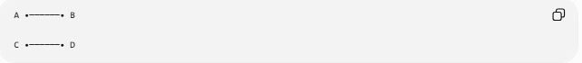
A •──────• B

C •──────• D
if both gaps have the same length.

Example
# Source: AI Source: Provided by: [Data Path: Persons Table -> ID Column: 1, Name_En Column: Motasem Essam] -> From: [ChatGPT] on [7/25/2026]
Given:
$$A\left(2 , 3\right)$$
and
$$B\left(8 , 11\right)$$
the point gap is:
$$g=\sqrt{{\left(8-2\right)}^{2}+{\left(11-3\right)}^{2}} \\ g=\sqrt{6^{2}+8^{2}} \\ g=\sqrt{36+64} \\ \boxed{g=10}$$

Point Gap vs. Point Distance
# Source: AI Source: Provided by: [Data Path: Persons Table -> ID Column: 1, Name_En Column: Motasem Essam] -> From: [ChatGPT] on [7/25/2026]
These concepts are closely related:
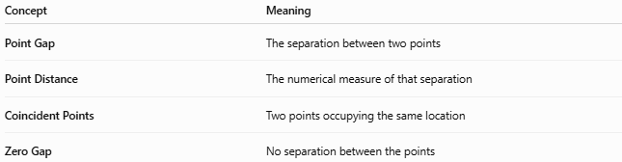
Concept | Meaning
Point Gap | The separation between two points
Point Distance | The numerical measure of that separation
Coincident Points | Two points occupying the same location
Zero Gap | No separation between the points
In standard mathematical terminology, distance between two points is the more formal term. Point Gap is useful as a descriptive term within a classification of gaps.

Relationship with Other Gaps
# Source: AI Source: Provided by: [Data Path: Persons Table -> ID Column: 1, Name_En Column: Motasem Essam] -> From: [ChatGPT] on [7/25/2026]
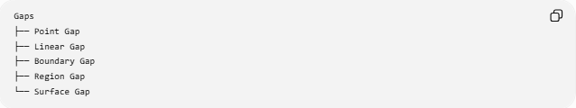
Gaps
├── Point Gap
├── Linear Gap
├── Boundary Gap
├── Region Gap
└── Surface Gap
The Point Gap is the simplest case because both objects being separated are points.

Real-World Applications
# Source: AI Source: Provided by: [Data Path: Persons Table -> ID Column: 1, Name_En Column: Motasem Essam] -> From: [ChatGPT] on [7/25/2026]
Point gaps can represent:
- Distance between two surveyed locations.
- Spacing between points in a coordinate system.
- Distance between GPS locations.
- Separation between vertices of a geometric figure.
- Distance between measurement points.
- Spacing between data points in geometric models.

Key Points
# Source: AI Source: Provided by: [Data Path: Persons Table -> ID Column: 1, Name_En Column: Motasem Essam] -> From: [ChatGPT] on [7/25/2026]
- A Point Gap describes the separation between two points.
- It is measured by the distance between those points.
- In 1D:
$$\boxed{g=∣x_{2}-x_{1}∣}$$
- In 2D:
$$\boxed{g=\sqrt{{\left(x_{2}-x_{1}\right)}^{2}+{\left(y_{2}-y_{1}\right)}^{2}}}$$
- In 3D:
$$\boxed{g=\sqrt{{\left(x_{2}-x_{1}\right)}^{2}+{\left(y_{2}-y_{1}\right)}^{2}+{\left(z_{2}-z_{1}\right)}^{2}}}$$
- $g>0$means the points are distinct.
- $g=0$means the points coincide.

Conclusion
# Source: AI Source: Provided by: [Data Path: Persons Table -> ID Column: 1, Name_En Column: Motasem Essam] -> From: [ChatGPT] on [7/25/2026]
A Point Gap is the simplest form of geometric gap: it represents the separation between two points and is quantified by the distance between them.

